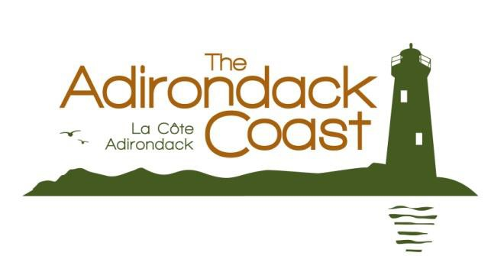Press Release

For More Information Contact: Amber Parliament 518.563.1000
amberp@northcountrychamber.com

For Immediate Release:

Adirondack Coast Offers Breathtaking Options for Rest and Recreation
Campgrounds, Parks and Beaches Provide Family Friendly Outdoor Experiences

Plattsburgh, NY– 3/24/2015 – The Adirondack Coast stretches across the western shores of Lake Champlain shouldered by New York’s Adirondack Mountains and the Green Mountains of Vermont. Throughout the region campgrounds, parks and beaches offer visitors plenty of opportunity for rest and recreation.

Camping

Camping on the Adirondack Coast offers a chance to get back to nature without leaving civilization too far behind. Enjoy the soothing sounds of an evening in the woods – the crackle of a campfire the thrilling call of a loon – and rejuvenate your senses. The area offers everything from state-owned and operated, to private campgrounds with family friendly amenities.

Island Camping

Sail along the beautiful shoreline and fall asleep to the quiet lap of waves on Valcour Island, which provides secluded and peaceful island campsites. Peru Dock is a state boat launch located on State Route 9 just 1.5 miles north of Valcour.

Parks & Beaches

The Adirondack Coast is renowned for its pristine beaches stretching along the shores of Lake Champlain or tucked away at the edge of a quiet river or mountain lake. Rent a stand-up-paddleboard, explore nature trails, dig in to a game of beach volleyball or kick back on one of the largest fresh water beaches in the United States and enjoy the incredible views – compliments of the Adirondack Mountains.

Ausable Point State Park 3346 Lakeshore Road Peru , NY 12972 518.561.7080 | Cadyville Beach  State Route 3  Cadyville, NY 12918  518.562.6800
Chazy Lake Beach  Route 374  Dannemora, NY 12929 | Cumberland Bay State Park  152 Commordore Thomas McDonough Highway, Plattsburgh, NY 12901. 518.563.5240
-more-

Macomb Reservation State Park  201 Campsite Road Schuyler Falls, NY 12985 518.643.9952 | Noblewood Park  Route 22  Willsboro, NY 12996  518.963.4598
Plattsburgh City Beach  4 Beach Road  Plattsburgh, NY 12901  518.324.7709 | Point au Roche State Park 19 Camp Red Cloud Road Plattsburgh, NY 12901  518.563.0369
Port Kent Beach
1 Route 373
Port Kent, NY 12975

Find the perfect spot for rest or recreation on the Adirondack Coast at goadirondack.com.

###

About the Adirondack Coast Visitors Bureau
The Adirondack Coast Visitors Bureau, a division of the North Country Chamber of Commerce, was established in 1994 as the official tourism promotion agency for the travel and tourism industry in Clinton County, NY. Based in Plattsburgh, NY, the Adirondack Coast Visitors Bureau contributes to the county's economic development and quality of life by promoting the region as a destination for leisure and group travel with a particular focus on history, agriculture and outdoor recreation including cycling, paddling, fishing, boating and skiing. For more information about Clinton County tourism, please contact the Adirondack Coast Visitors Bureau at 518.563.1000, visit goadirondack.com or log onto Facebook.com/AdkCoast.

