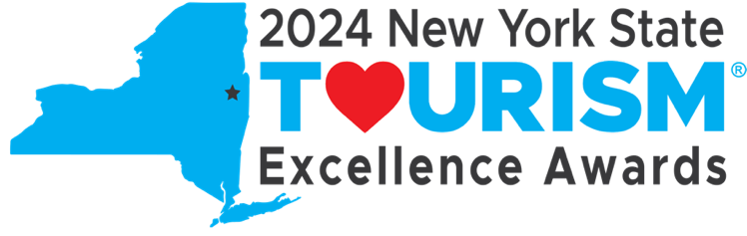
2024 Tourism Excellence Awards
Nomination Preparation Document

The purpose of this document is to help prepare your Tourism Excellence Awards nomination prior to submitting with the form. Good luck!

Deadline for Submissions: Saturday, May 25 at 11:59 PM E.T.

Please prepare:

- I. Nominator information:
  - Name, email, phone number, organization, organization address
  - If you are nominating work done for a client, please identify the Agency as the Nominator
- II. Nominee information:
  - Nominated program/project/person, nominee organization, organization address, website (if applicable)
  - Key contact person name, email, and phone number
  - If you are nominating work done for a client, please identify the Client as the Nominee
- Awards Category/Subcategory
- If you are nominating a program/project:
  - Budget of nominated organization (over or under $500,000)
  - Ensure that the program/project references activity and outcomes that occurred between June 1, 2022 and December 31, 2023

Summary description of nominated program, project, or person: In 2-3 sentences, please provide an overview of the program, project or person you are nominating.

Why does the program / project / person merit a Tourism Excellence Award?
Please explain what makes this program/project/person unique and exceptional. Include specific details such as challenges overcome, areas of impact, key elements of development, funding sources, future plans, lessons learned, etc. (500 word maximum)

For Program/Projects ONLY: How does the program/project meet the award category description and requirements, especially in the key areas of ideas or objectives, strategies, tactics, and results? 500 word maximum. If you are nominating an individual, please type N/A.

For programs/projects ONLY: Please list key participants in the project, including public agencies, local businesses, tourism promotional agencies and community groups. 500 word maximum. If you are nominating a program/project, please type N/A.

For individual nominees: Provide anecdotes, examples of work activity, testimonials, and any other qualitative or quantitative results to demonstrate innovation or inspirational leadership. 500 word maximum. If you are nominating a program/project, please type N/A.

III. Supporting documentation:

If applicable, you may provide materials* to support your nomination.
*Please ensure that your file(s) is/are 5 MB max before uploading or you may risk losing your work. If your supporting documentation exceeds 5 MB, you may provide a file-sharing link (WeTransfer, Dropbox, Google Drive etc.).

